|  |
| --- |
| 新东方在线英语学习 |
| 新概念 2 册 |
| Lesson65 |



扫一扫。更多有趣的英语资讯。

1. versus prep. 对

A vs. B

介词接 名词代词 动名词

1. Christmas n. 圣诞节Merry Christmas ! Christmas Eve
2. ought modal verb. 应该

情态动词

ought to do sth.= should do sth.

3 circus ['sə:kəs] n.马戏团

4 present [pri'zent, 'prezənt] n.礼物

5 accompany [ə'kʌmpəni] 陪伴，随行

6 approach [ə'prəutʃ] v.走近

7 ought [ɔ:t] modal verb 应该

8 weigh [wei] v.重

9 fortunate ['fɔ:tʃənət] a.幸运的

# Lesson 65 单词讲解

Key points:

复习非谓语动词复习情态动词 情态动词的虚拟

# Lesson 65 课文&语法讲解

dress up as Father Christmas and accompany by a 'guard of honour' of six pretty girls, he set off down the main street of the city ride a baby elephant call Jumbo.

Set off set out 出发

1. Dressed up as Father Christmas and accompanied by a 'guard of honour' of six pretty girls, he set off down the main street of the city riding a baby elephant called Jumbo.

Dressed up 打扮

He Set off 一主一谓 搭配好了 粉色部分是非谓语动词

1. He should have known that the police would never allow this sort of thing.

宾语从句

this sort of thing should have known ???

should 情态动词

should + do 真实

现在应该做

should + have done

过去应该做

(过去本来应该做,但实际上没做)

1. He should have known that the police would never allow this sort of thing.
   * should
   * should + have done 情态动词 虚拟
   * ought to + have done

(过去本来应该做,但实际上没做)

1. A policeman approached Jimmy and told him he ought to have gone along a side street as （因为）Jumbo was holding up the traffic.
   * 情态动词 虚拟
   * should + have done = ought to + have done (过去本来应该做,但实际上没做)
   * shouldn’t have done
   * need have done
   * could / would / might + have done
2. Though Jimmy agreed to go at once, Jumbo refused to move.
3. Fifteen policemen had to push very hard to get him off the main street.

Had to 必须 push 动词 to表目的做非谓语

1. The police had a difficult time, but they were most amused.

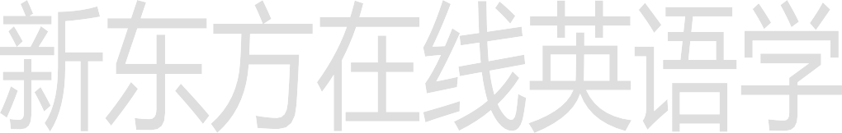

1. 'Jumbo must weigh a few tons,' …
2. …'so it was fortunate that we didn't have to carry him.

形式主语 主语从句

1. … we should arrest him, but as he has a good record, we shall let him off this time.'

**Lesson 65 知识拓展**

Encourage your children to try new things, but try not to them too hard.

1. draw
2. strike
3. rush
4. push

(2009 全国 32)

What do you mean, there are only ten tickets? There be twelve.

1. should
2. would
3. will
4. shall

(2009 全国 25)

What do you mean, there are only ten tickets? There be twelve.

1. should
2. would
3. will
4. shall

(2009 全国 25)

* + 情态动词 虚拟
  + should + have done = ought to + have done (过去本来应该做,但实际上没做)
  + shouldn’t have done
  + need have done
  + could / would / might + have done

They have arrived at lunchtime but their flight was delayed.

1. will
2. can
3. must
4. should

(2011 课标 全国 32)

They have arrived at lunchtime but their flight was delayed.

1. will
2. can
3. must
4. should

(2011 课标 全国 32)

I have watched that movie – it’ll give me horrible dreams.

1. shouldn’t



1. needn’t
2. couldn’t
3. mustn’t (2010 山东 25)

I have watched that movie – it’ll give me horrible dreams.

1. shouldn’t
2. needn’t
3. couldn’t
4. mustn’t (2010 山东 25)